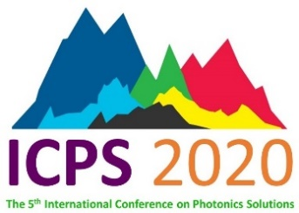
The 5th International Conference on Photonics Solutions
(ICPS 2020)
28-31 July 2020, Royal Cliff Beach Hotel, Pattaya
Sponsor Form
Organization: ……………………………………………………………………………………………………………………..............................
Name of sponsor: ……………………………………………………………………………………………………………………..............................
Address: ……………………………………………………………………………………………………………………..............................
Telephone: ……………………………………………………… Fax: ……………………………...........................………………….
e-mail: ……………………………………………………………………………………………………………………..............................
We would like to support the ICPS 2020 and we have transferred money to Krungthai Bank Branch: Kasetsart University, Account Name: ICPS2020, Account Number: 985-2-35992-4 Amount.......................................................Baht
Level of support | Publicity and other benefits
 | Logo on the abstract book | Logo on Facebook (Cover Photo) of ICPS2020 | Logo on the conference gift bag | Logo at the stage | Logo on the web site ICPS2020 | An exhibit-ion booth | 2 lunches and  4 breaks for 2 persons | Banquet  For 2 persons | Waived registration fee / A room at Rayong Marriott Resort & Spa for 2 persons and 2 nights
5,000 Baht
5,000 Baht
10,000 Baht
20,000 Baht
20,000 Baht
30,000 Baht
50,000 Baht
60,000 Baht
100,000 Baht |  |  |  |  |  | (2 booths)
*** The sponsors can select the position of their booth in order of date of payment submission ***
The organizers would like to express their gratitude for your support of ICPS 2020
Further information: Please contact Asst. Prof. Dr. Pongsakorn Jantaratana, Tel: (+66) 086-669-1508
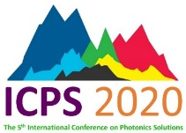
Please send this form back to E-mail: fscipsj@ku.ac.th (Asst. Prof. Dr. Pongsakorn Jantaratana)

